We declare that we have completed this assignment completely and entirely on our own, without any consultation with others. We have read the UAB Academic Honor Code and understand that any breach of the Honor Code may result in severe penalties.
We also declare that the following percentage distribution faithfully represents individual group members’ contributions to the completion of the assignment
Name | Overall Contribution (%) | Major work items completed by me | Signature or initials | Date
Abhi Bedi |  | Performing data cleaning activities to structure data and get it ready for classifier model. Tasks also included visualizations performed on data prior to understand internal relationship and post model run to display results. Lastly, training the classification model and interpreting results. Report writing. | AB | 12/05/2025

Predicting Movie success using random forest regression and classification
UAB CS 663: Data Mining

ABSTRACT
Our approach focuses on predictive modeling for movie performance using Random Forest Regression and Random Forest Classification. The goal is to understand which factors contribute to financial success and to construct a machine learning model capable of predicting both revenue outcomes and a success metric (Hit/No Hit).
Extensive data cleaning, feature engineering, and exploration of data analysis were conducted to ensure results are reliable, valid and credible. We formed visualizations from techniques to identify potential data leakage and model nonlinear relationships between data. This report focuses on regression and classification pipelines, including preprocessing, encoding strategies, model construction and performance evaluation. Lastly, includes some thoughts upon furthering the approach for future topics to explore to refine data and/or model.
BACKGROUND
Predicting movie success is a difficult task due to many factors being at the interplay. This predictive model could help give insight into what factors need to be focused upon by investors and producers to make an informed financial decision. We analyze movie datasets containing production budgets, revenue outcomes, critic metrics, genre attributes, and actor and their talent metadata. We apply Random Forest models—known for their ability to capture nonlinear relationships and handle heterogenous data—to two connected prediction tasks: (1) regression for financial estimation and (2) classification for identifying “hits”. This term project emphasizes importance of robust preprocessing, avoidance of revenue leakage and careful evaluation of class imbalance.
PROPOSED METHOD
Dataset Overview
The dataset was put together using several different sources. This includes Kaggle’s IMDB dataset and others. The dataset was narrowed down to 578 film entries and refined to 576 valid records post data cleaning tasks. Features included:
- Financial attributes: production budget, domestic/international/worldwide gross
- Computed metrics: profit proxy, ROI proxy, log-transformed revenue.
- Critical reception: Tomatometer rating and review count.
- Talent attributes: director names, lead actor names, actor tier, Oscar status, star power score.
- Genre metadata: multi-label genre lists and primary genre extraction.
- Flags: is_franchise, is_sequel, is_animated, is_live_action, is_standalone.
The dataset is heterogenous, combining numerical, categorical, ordinal, and multi-label features. This requires tailored cleaning and encoding prior to analysis or model training.
Data Cleaning and Preprocessing
When cleaning the data we followed a structured approach:
- Handling Missing Values: numeric features were computed using median values. Categorical features computed used mode and all dates converted to a datetime format.
- Removing invalid data: after verifying online sources we found that data included incorrect and unrealistic upper bounds in budgets which would have caused huge issues with training being a big outlier value. Further the proxy of success is calculated using production budgets and worldwide gross so would have skewed the ROI measure.
- Normalization and Encoding: utilized string libraries and python to separate and split genres and standardize all text. We created primary genre columns to understand relationships between data later in the EDA steps. Further Multi-Label Encoding is performed upon genres indicating columns and one-hot encoding performed on primary genre.
- Actor Metadata Cleaning: cleaned actor and director names and standardized them. Added categorical fields like lead_actor_tier, lead_actor_status, lead_actor_has_oscar and constructed a power score.
- Leakage: lastly, all revenue related variables (worldwide_gross, dometic_gross, profit_proxy, ROI proxies, etc.) were excluded from classification features to prevent the model from “cheating”.
Exploratory Data Analysis
One of the main tasks in this section was to understand correlation. With initial plots including revenue-based variables with ROI. However, we wanted to understand the relationship of success about the nonlinear variables. With exclusion of revenue-based variable, we saw a weak linear relationship with ROI which would be expected as it is volatile inherently.
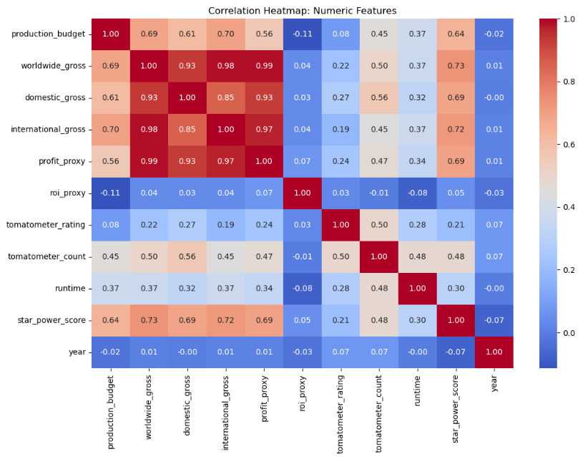
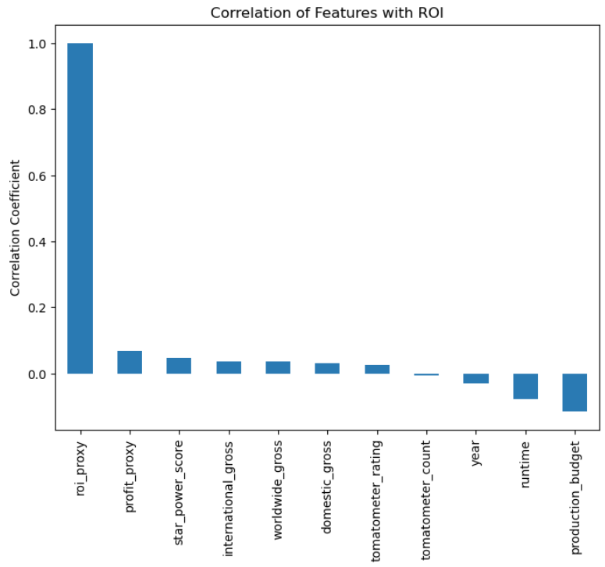
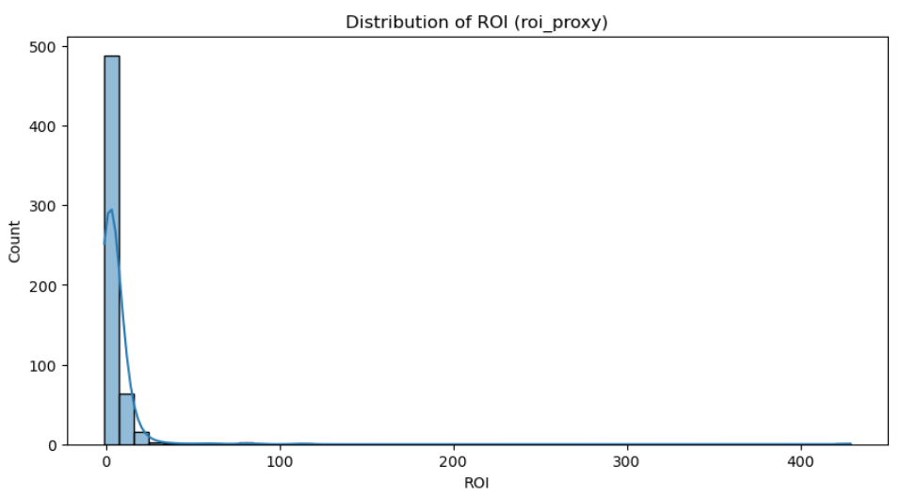
- Feature Distributions: Production budgets were right skewed with most films having moderate budgets and few high budget outliers. Star power and critic ratings show normal distribution. ROI was heavily long tailed due to low-budget films achieving unexpectedly high profit ratios.
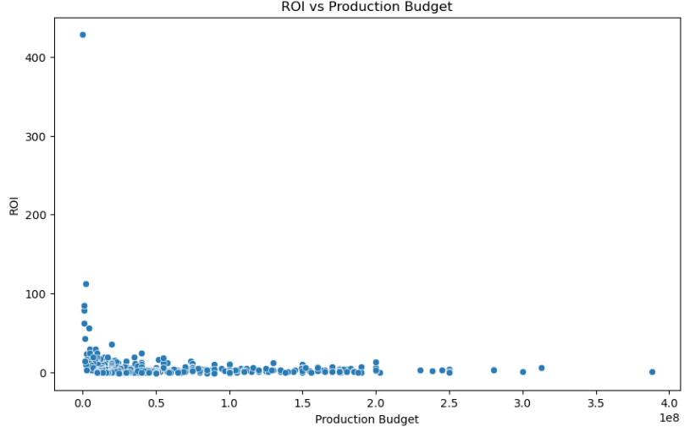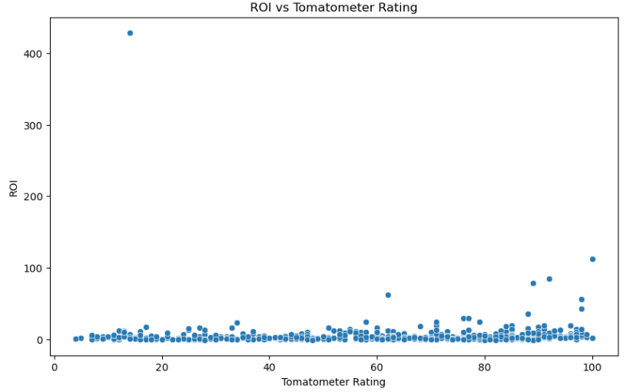
- Genres like drama, action and comedy dominated the data, however westerns and classics were sparse.

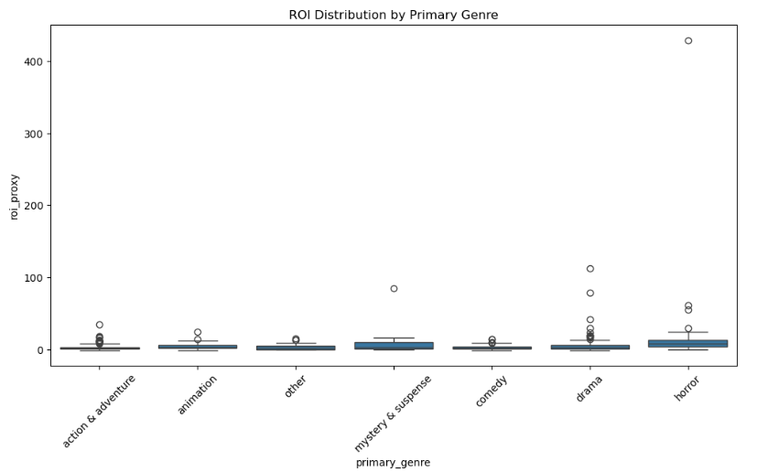

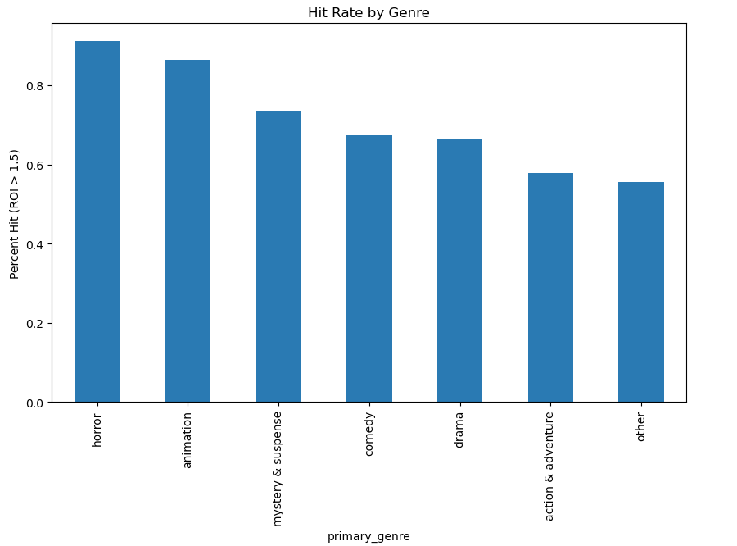
- There were some obvious trends observed too like higher star power equating to higher ROI
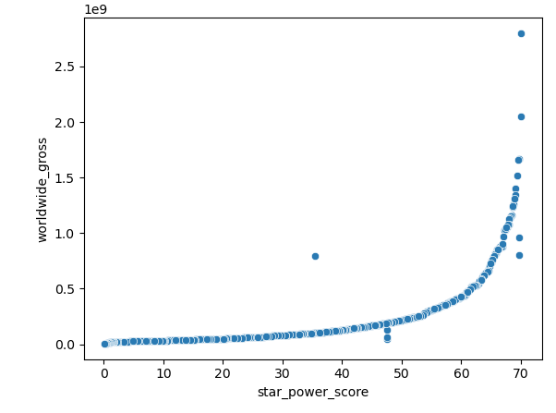
Classification Model (Random Forest Classifier)
We created labels and criteria for what defines a “hit” vs “not hit” a value of ROI proxy > 1.5 to show 1.5x times the return of the production budget should qualify a good return on investment.
Feature selection after eliminating all revenue-based features, predictors included:
- production_budget
- tomatometer_rating
- tomatometer_count
- runtime
- year
- star_power_score
- primary_genre
- directors (high cardinality)
- lead_actor_clean (high cardinality)
- lead_actor_status
- lead_actor_tier
Encoding strategies include one-hot encoding for primary genre as it is a low cardinality, actor tier and status with label encoding since belong to ordinal category and directors and lead actors with target encoding since these belong to high-cardinality.
Further, for the classification model we created a 75/25 split for creating train/test data.
The classification pipeline, was built from train/test split, encoding categorical variables and passed into classifier in a unified manner using ColumnTransformer.
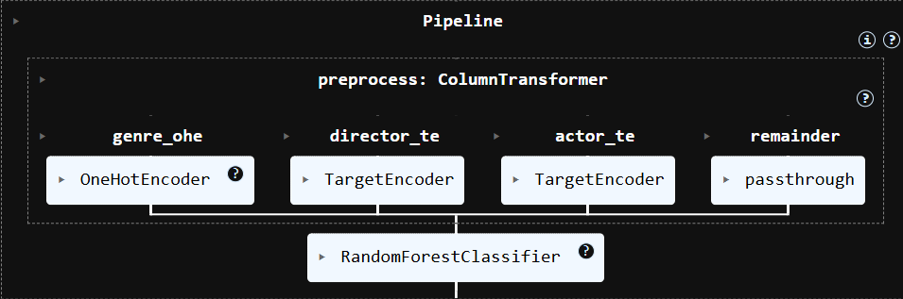
Regression Model (Random Forest Regressor)
EXPERIMENT RESULTS
Classification Results
Based on Precision-Recall tables we can say classification model had 66% accuracy and following metrics:
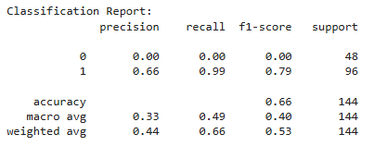
Confusion Matrix showed 99% success when classifying “Hits” getting 95/96 but performed extremely poor when classifying “Not Hits”. This gives us insight into a possible class imbalance here because “Hits” seem to be twice the size of “Not Hits”
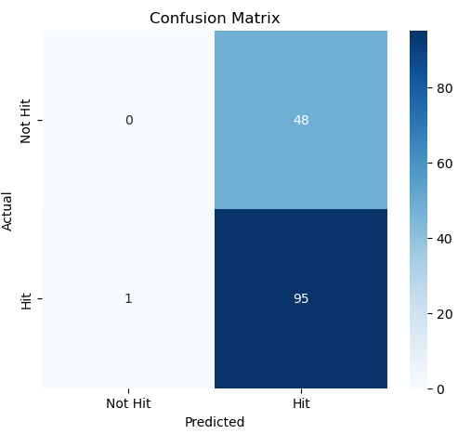
However, ROC curve being a cumulative assessor shows the model would be optimized at 0.4 threshold by the ratio of True Positives and False Positives.
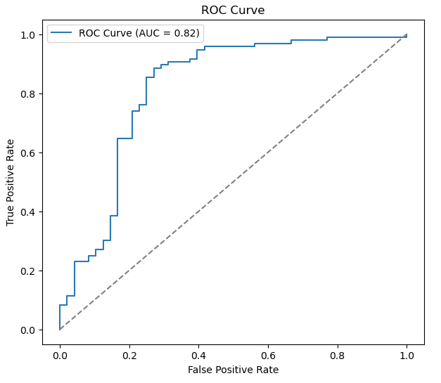
DISCUSSIONS
Classification: model exhibits a strong ranking ability by ROC-AUC score of 0.82. However, model suffers from a majority class that is overfitting. Non-hit recall rate is 0.0. This primary issue here is class imbalance + weak separation between classes across independent features. There are other unobserved factors that could be causing ROI instability while influencing it. It does seem to be the case that Random Forest Trees prefer a majority class (bias) along with weak class predictors which certainly do not help the model from avoiding overfitting.
PLAN FOR FUTURE WORKS
Future work covering classification models with more time time to devote include applying:
- Balancing techniques to balance the random forest
- Testing against newer models like XGBoost
- Collecting more data to inherently solve the imbalance
- Further cleaning and sorting through lead actor’s dataset to learn better relationships between actors-directors and ROI.
Our classification and regression models, pre-processing techniques, feature selection and encoding techniques provide a strong foundation for further experimentation and more comprehensive predictive modeling.

